Asprey Case Studies
Case Study One – Property Management Transformation at LFHA– Full Suite
Background
Leeds Federated Housing Association (LFHA) has been dedicated to providing safe, affordable homes since 1975. Serving communities across Leeds, Wakefield, and North Yorkshire, LFHA has continually focused on delivering homes that people want to live in, while ensuring they are safe, sustainable, and well-managed. However, LFHA's property management systems were becoming increasingly fragmented and inefficient, leading to significant operational challenges.
Challenge
LFHA was operating a collection of disparate systems for property management. This complex and disjointed arrangement led to several challenges:
- Information Accessibility: Difficulty in accessing timely and accurate information, hindered efficient operations.
- Manual Processes and Data Errors: Reliance on manual processes, with minimal data validation and ownership, resulted in data errors and inefficiencies.
- Excessive Reporting Time: The reliance on multiple data sources, hence manual checks and reconciliation, resulted in long reporting times and a lack of confidence in report accuracy.
- Compliance and Audit Issues: No clear audit trail, made it difficult to ensure compliance in property management and respond effectively to audits.
- Lack of Evidence for Reporting: No consistent "golden thread" of data to support accurate and defensible reporting, especially for compliance management.
These challenges led to difficulties in decision-making, siloed work practices, and resource-intensive processes, impacting both operational efficiency and service delivery.
Solution
LFHA embarked on a comprehensive procurement process to find a new solution with primary goals to improve functionality, streamline operations, and realise value for money, whilst enhancing services for their residents.
Asprey’s solution stood out due to its potential to drive operational efficiencies and improve data integration. Asprey provided expert insight into LFHA's existing systems, recommending a strategy for system rationalisation and cost reduction. This approach aligned with LFHA’s aim to modernise its property management infrastructure.
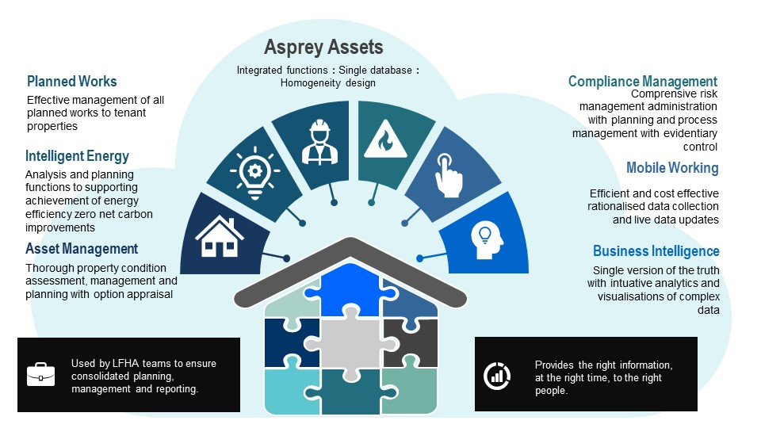
Implementation
Asprey’s team worked closely with LFHA throughout the implementation to ensure the solution was tailored to their specific aspirations and needs. The integration of Asprey Assets involved data rationalisation and process automation, significantly improving operational efficiency across the organisation.
Key Benefits:
The team at LFHA has reported a range of organisation and user benefits:
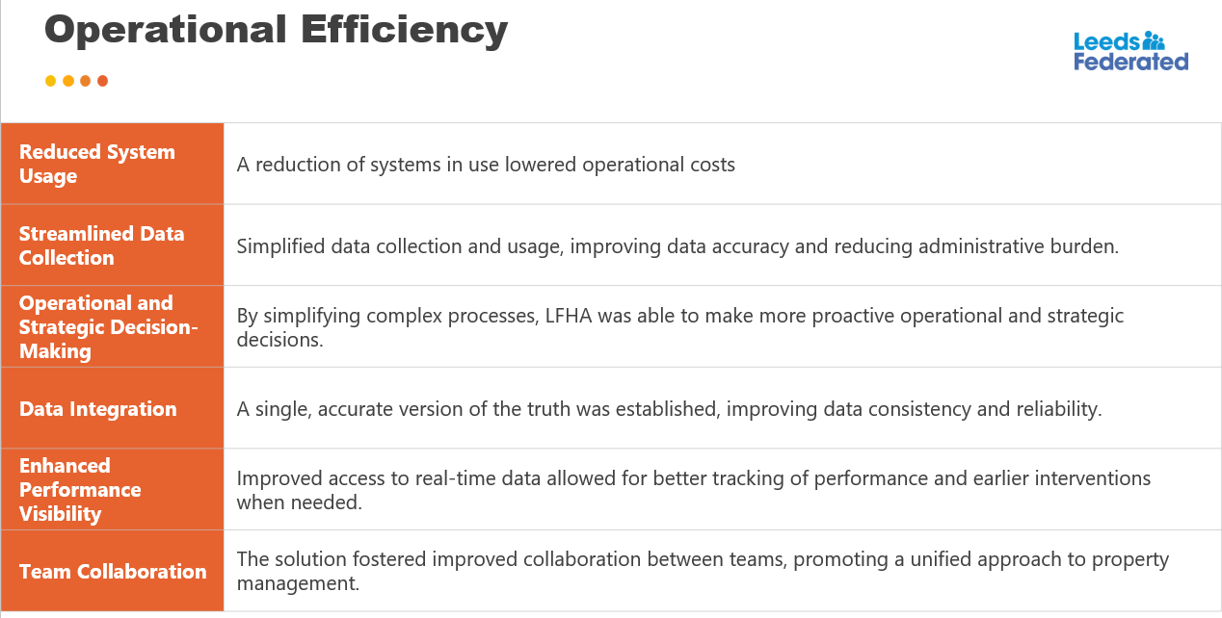

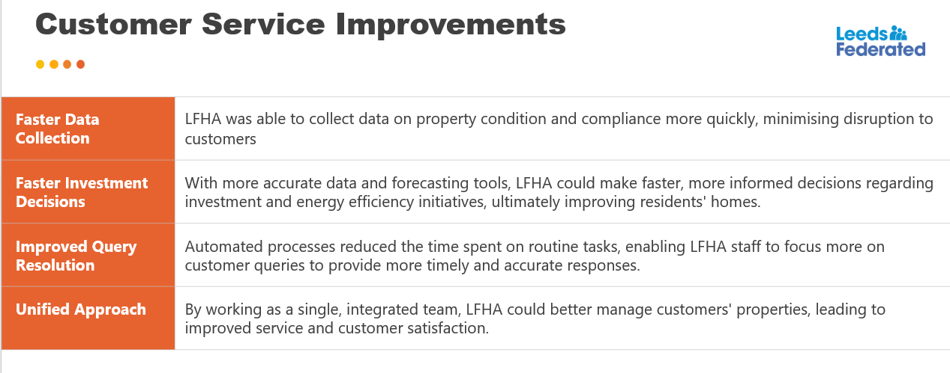
Outcome
By utilising Asprey Assets in combination with Sava Intelligent Energy, LFHA was able to secure £3M in grant funding under the SHDF Wave 2.1 initiative. This funding will be used to further enhance the energy efficiency of LFHA's housing stock, improving sustainability and reducing energy costs for residents.
Conclusion
Asprey Assets has transformed LFHA’s property management operations, resulting in significant improvements in efficiency, data accuracy, and service delivery. By integrating systems and automating processes, LFHA has not only optimised processes but also enhanced the customer experience. The solution has positioned LFHA to make informed, data-driven decisions and is helping them meet both operational goals and regulatory requirements with greater ease.

.

Case Study Two – bpha’s successful transition to Asprey Assets for enhanced compliance and reporting (and now Asset Management)
Background
bpha, based in the Oxford to Cambridge Arc, is dedicated to providing high-quality, value-for-money services to its customers. The organisation focuses on developing energy-efficient, sustainable, and affordable housing solutions. With a portfolio that includes general needs rent, retirement living, and homes for shared ownership, bpha manages over 19,500 homes and employs 500 staff.
Challenges
bpha's primary concern was with the inefficiency of their compliance management processes. Their legacy system, though still functional, was cumbersome and required excessive administrative effort to maintain. It offered minimal actionable data and lacked the comprehensive features necessary for efficient and effective compliance management. Consequently, the team found themselves spending too much time on manual administration, with little return in terms of usability or insight.
Key challenges included:
- Inadequate management of compliance tasks
- Lack of centralised reporting capabilities
- Manual tracking and management of evidence
- Limited mobile access and data validation for field staff
- Inconsistent execution of site checks
- Limited automation and reporting capabilities
Solution Objectives
When searching for a new solution, bpha focused on several key objectives:
- Centralised Management: To streamline the management and reporting of compliance tasks, from any location.
- Detailed Action Management: Ability to manage actions more efficiently with clear tracking.
- Evidence Management: Centralised storage of compliance-related evidence.
- Mobile Working: Data validation capabilities for field staff working on-site for consistent execution of checks and tasks.
- Reporting Improvements: Enhanced reporting for more accurate tracking and insights.
- Process Efficiencies: Automation to reduce manual efforts and improve operational efficiency.
- Customer Safety: To help assure customer safety by ensuring all compliance tasks were properly tracked and completed.
Solution Implementation
After evaluating several options, bpha selected Asprey Assets as their compliance management solution. They were impressed with not only the functional capabilities but also the BI and reporting features of Asprey Assets, which stood out compared to other solutions.
The implementation process was collaborative, with bpha and Asprey working closely to address specific requirements. Key implementation milestones included:
- Integration: Asprey Assets integrated seamlessly with bpha’s existing contractor portals and systems, including a connection to MS Dynamics via provided APIs.
- Customisation and Enhancements: In response to bpha's specific needs, Asprey enhanced its solution to improve contractor cost control. By leveraging Asprey’s planned works functionality, bpha could now better manage the costs associated with servicing and inspections, a critical aspect of their compliance operations.
- Mobile Working and Validation: The solution enabled mobile working with data validation, ensuring that compliance tasks could be completed efficiently and accurately on-site.
Results
The transition to Asprey Assets resulted in significant improvements for bpha:
- Improved Reporting and Clarity: BI and reporting features delivered better visibility into compliance tasks, reducing uncertainty and administrative burden.
- Automation: bpha achieved 99% automation for their gas servicing process
- Cost Control: cost management features allowed bpha to gain greater control over service costs
- Efficiency Gains: The solution has led to substantial improvements in process efficiency, freeing up valuable time for staff and reducing administrative workloads.

Expansion of Use
Following the success of the compliance management solution, bpha has replaced its incumbent asset management system with Asprey Assets, as it provided superior functionality at a lower cost.
Conclusion
bpha’s transition to Asprey Assets has significantly enhanced its compliance management processes, leading to reduced administrative efforts, improved reporting, and greater assurance of customer safety. The collaboration with Asprey enabled the organisation to meet its objectives of improving efficiency, reducing costs, and ensuring the highest standards of compliance across its operations.

Case Study Three – Look Ahead – Operational Asset Management + Strategic Asset Management
Background
Founded in 1973, Look Ahead is a leading provider of affordable, high-quality accommodation and support services for individuals with mental health issues and learning disabilities, and young people. With a workforce of over 1,000 staff, Look Ahead supports more than 6,500 individuals annually across London and the Southeast. Its mission has remained consistent for nearly 50 years: to provide exceptional care, housing, and support to vulnerable populations.
Challenge
Look Ahead’s operational and strategic asset management systems were outdated, fragmented, and heavily reliant on manual processes. Their main challenges included:
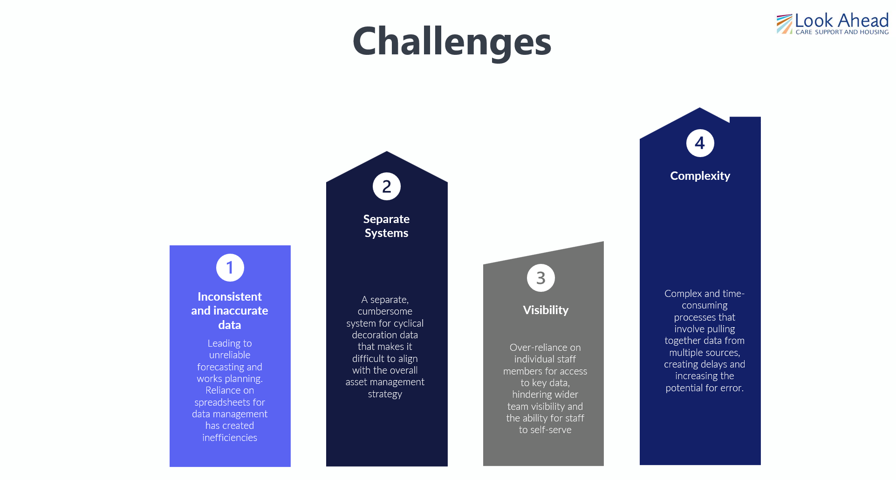

Objectives
Look Ahead aimed to address these issues through a comprehensive procurement project that would streamline its asset management function. Key objectives were to:
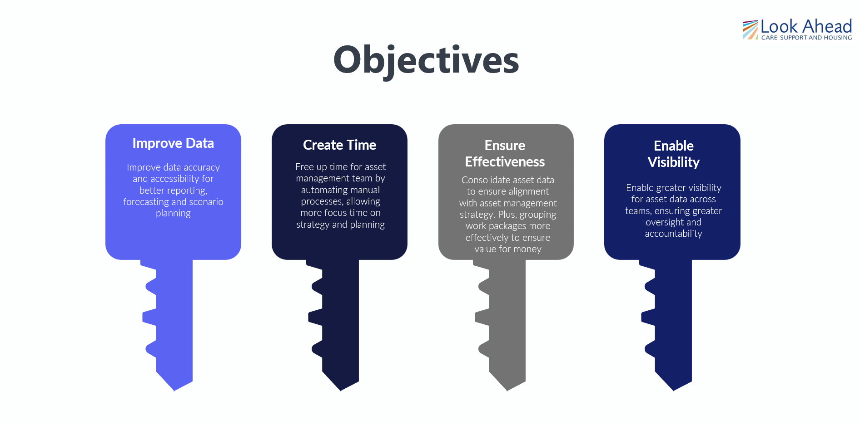
Solution
Look Ahead had previously moved away from its original asset management solution, relying on a mix of spreadsheets and fragmented data sources to manage property conditions and work schedules. Our consultants conducted a comprehensive analysis of their existing data and worked closely with the Look Ahead team to ensure that data for onward use was as complete and accurate as possible.
The implementation of the new operational asset management system brought immediate benefits, including:
- Improved Data Quality: Enhanced accuracy and consistency across asset data, ensuring reliable decision-making.
- Reduction in Administrative Burden: Automation of previously manual processes, allowing staff to focus on strategic tasks.
- Greater Fiscal Control: Improved clarity in financial oversight, enabling better budgeting and resource allocation.
- Improved Audit Outcomes: Streamlined processes and more reliable data led to better audit results.
Strategic Objectives
With the operational asset management system in place, Look Ahead turned its focus to achieving long-term strategic goals. Objectives include:
- Maximising the efficiency of its assets, ensuring optimal use and value over time.
- Making informed decisions about investment in assets, with a focus on cost-effectiveness.
- Exploring alternatives such as asset disposal or transfer when necessary.
- Rationalising its operating areas to improve management efficiency.
- Identifying new acquisition opportunities within core operating areas to expand its service offerings.
- Gaining a deeper understanding of customer segments and needs to tailor asset management services accordingly.

Implementation of AspireBI
To further enhance its strategic asset management capabilities, Look Ahead selected Asprey’s AspireBI solution in November 2024. AspireBI is designed to support data-driven investment decision-making, to improve the long-term management and value of Look Ahead’s property portfolio. The solution is currently being implemented, with a clear vision of streamlining strategic asset management and providing greater insights into future opportunities.
Conclusion
Look Ahead’s journey to operational excellence and strategic growth has been marked by a commitment to data accuracy, automation, and efficiency. Through the implementation of a new asset management system and the upcoming integration of AspireBI, Look Ahead is poised to further improve its operational effectiveness and achieve its strategic objectives for the future.

