Appendix A – Apprenticeship Standard Sub Criteria Guidance

Introduction
This document serves as a guide for the providers adding apprenticeship standards. The information provided will be used to present the details and offerings from you the provider to potential customers on the YPO website. Providers will be required to ensure all details are accurate and kept up to date using the supplier portal.
The web link for the supplier portal is as follows;
https://amp.ypo.co.uk

- Registering for the portal

Providers can only register and be accepted for an account on the supplier portal once they have been successfully appointed to the YPO Apprenticeships and Associated Training framework.
Providers must use this portal to provide all apprenticeship standards offered and keep information up to date on available standards along with provider details as outlined in the specification.
To support the management of the framework please provide a generic email address for monitoring Direct Awards and Further Competitions when registering for an account.
To register for an account, providers need to access the link above which will open the log in page where providers can ‘register for an account’
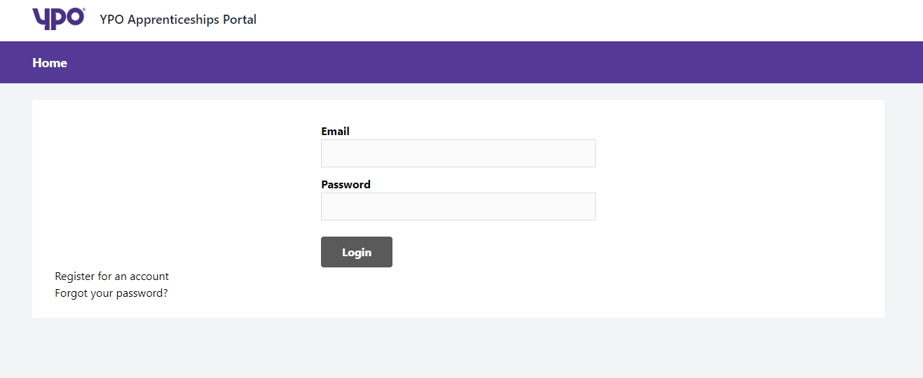

When registering for an account, providers must complete all sections of the registration page, and provider a unique email address which can be used for direct award and further competition purposes;
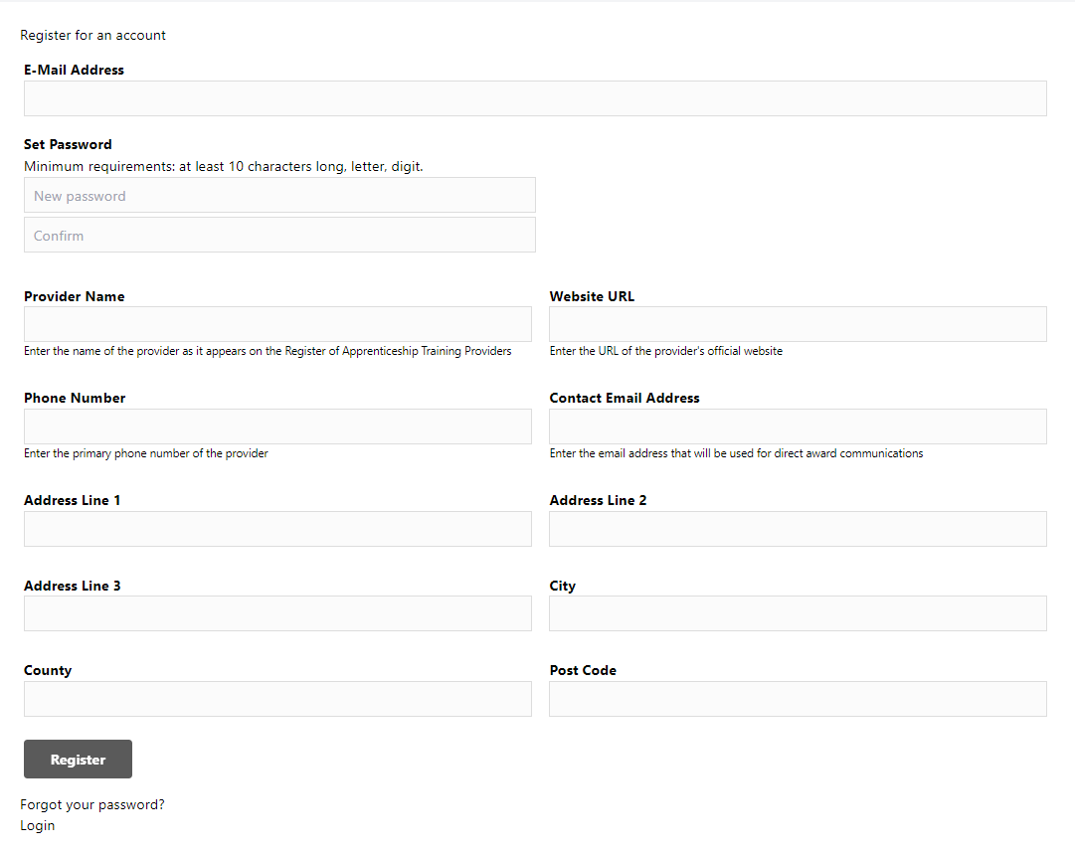
Note: It is important to ensure that all the above-mentioned sections are completed accurately to ensure that the provider's information is correctly recorded.
Once all information is completed, please click register to create the account. Providers will then be asked to confirm the account as per below;
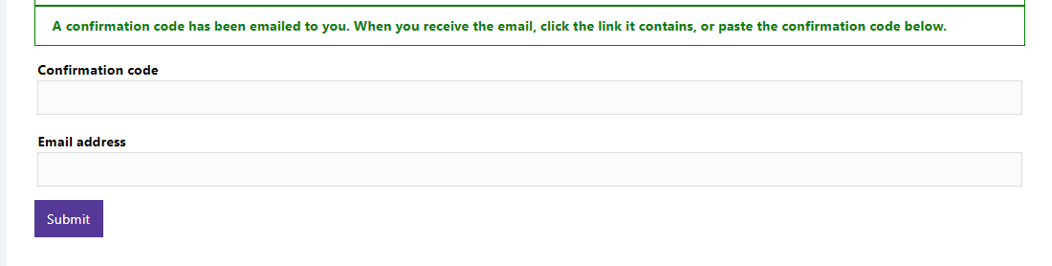
Once YPO approves this account, and providers have been successfully appointed to the framework then providers will then be able to add standards which will become visible on the YPO apprenticeships website.

- Adding provider information

Once the provider account has been approved by YPO, providers must add the provider information sheet (Appendix C)
In this section, providers need to attach a copy of the provider information (Appendix C), and can also make any adjustments to contact details.
This section also provides the opportunity to add any default standard information, which will then hold this as information to be used at a later stage when adding standards. (Please note this information will be adjustable for each standard if required and does not need to be completed at this stage);
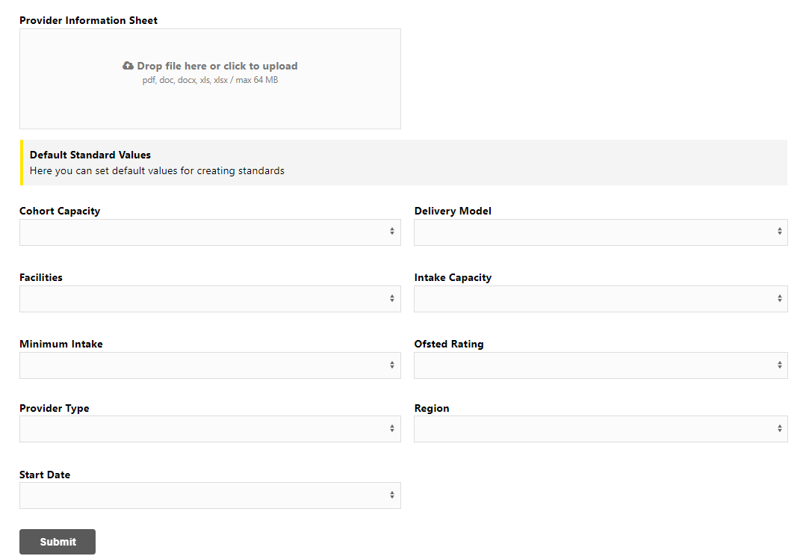

- Adding standards

After completing the provider information, there is the option to add standards.
This will take providers to a new screen where standard information can be added. All sections must be completed (please note that any default information previously entered will be on screen but can be adjusted according to how the standard is delivered).
To ensure accuracy and completeness of information, it is mandatory that all sections on this page are completed accurate for each standard delivered. It is the providers responsibility to ensure the information is correct and maintained/updated.
The following sections will allow a multiple selection;
- Cohort Capacity
- Intake Capacity
- Delivery model
- Facilities
- Start date
- Region

The framework response (appendix D) and framework pricing for the relevant standard (appendix B), must be uploaded for the standard.
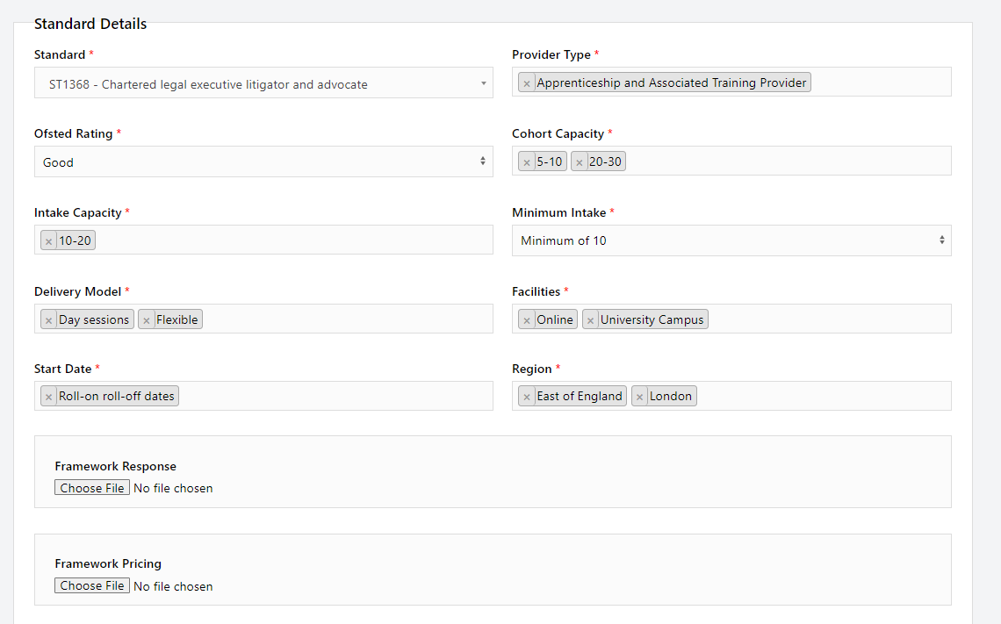

Once all information is completed, click ‘submit’ and this will send the information to YPO for verifying. There will then be an option to add another standard.
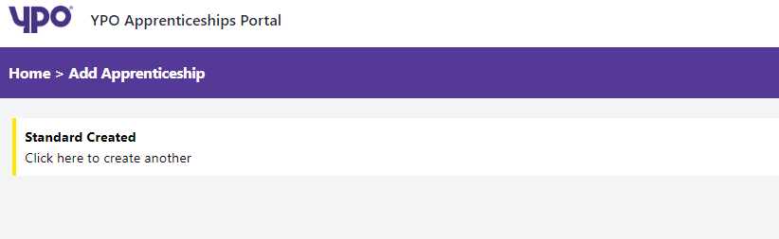

Note: It is important to ensure that all the above-mentioned sections are completed accurately to ensure that the standards’ provided information is correctly recorded.
Please note, the supplier portal will be updated weekly with any new or amended standards being added.

- Amending and deleting standards
Providers must maintain all information in the portal to ensure standards are kept up to date and hold relevant details. If a standard(s) needs amending or removing at any time, use the ‘home’ button to view all standards listed.
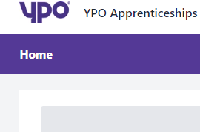
On this page there will also be the option to edit the profile details, amend any standards and also add another standard.

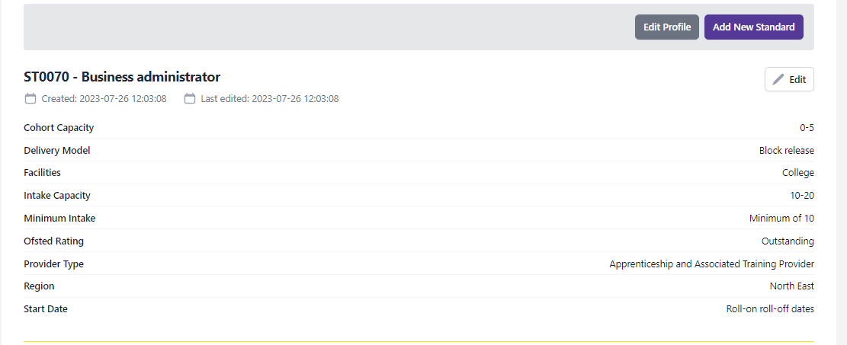
Using the edit function, will then return providers to the page as shown on step 3. And the standard can be edited or deleted at this point.

- Summary
It is important for all providers to maintain information on the YPO website to ensure customers have full availability of all standards available. Therefore, all provider information and standards available must be maintained by providers using this supplier portal.
Any questions or concerns please contact YPO apprenticeships@ypo.co.uk

